Ministry of Education of the Republic of Moldova

Technical University of Moldova

Department of Software Engineering and Automatic

**REPORT**

*CDE*

Laboratory work no. 5

**BJT configurations and modes of operation**

Performed by:

st. gr. FAF-161 Terman Emil

Verified by:

Prof. dr. hab. O. Lupan

(30.11.2017)

Chişinău - 2017

**Topic:** Bipolar transistor characteristics

**The purpose of the work:** to get familiarized with the basic use of a curve tracer, to obtain the characteristics of bipolar junction transistor (BJT).

**The scheme:**

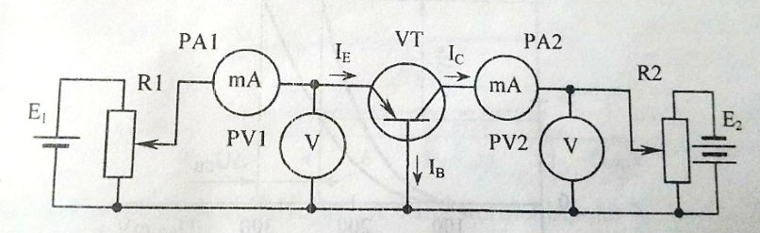

***Fig.1:*** *Common emitter configuration of* ***bipolar*** *junction* ***transistor*** *(BJT)*

1. Measure and draw **common-emitter input** characteristics of bipolar transistor for UCB= 0 and UCB=-5V at room temperature.

UC = 0~280 mV

|  |  |  |  |  |  |  |  |  |  |  |  |  |
| --- | --- | --- | --- | --- | --- | --- | --- | --- | --- | --- | --- | --- |
| *UC, mV* | | *20* | *40* | *60* | *80* | *100* | *120* | *140* | *160* | *200* | *240* | *280* |
| *IE, mA* | ***UCB = 0V*** | 0.003 | 0.01 | 0.02 | 0.05 | 0.12 | 0.27 | 0.53 | 1.02 | 3.46 | 8.33 | 16.4 |
| ***UCB = -5V*** | 0.007 | 0.01 | 0.03 | 0.07 | 0.15 | 0.31 | 0.65 | 1.30 | 4.39 | 11.3 | 23 |

2. Experimental datas for increasing output characteristics of bipolar transistors in BC connection:

|  |  |  |  |  |  |  |  |
| --- | --- | --- | --- | --- | --- | --- | --- |
| ***UCB, V*** | | ***0*** | ***2*** | ***4*** | ***6*** | ***8*** | ***10*** |
| ***IE*** | ***IE = 5mA*** | 4.7 | 4.8 | 4.8 | 4.9 | 4.9 | 5 |
| ***IE = 10mA*** | 9.7 | 9.8 | 9.8 | 9.9 | 9.9 | 10 |

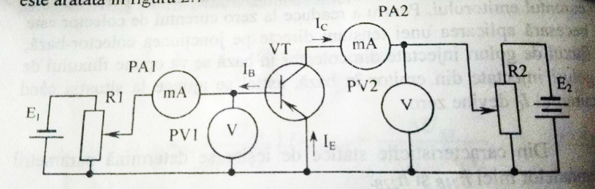

**Fig. 2:**The experimental drawing scheme of the static characteristics of the bipolar transistor in the EC connection

3. Experimental data’s for increasing input characteristics of bipolar transistors in EC connection:

|  |  |  |  |  |  |  |  |  |  |  |  |  |
| --- | --- | --- | --- | --- | --- | --- | --- | --- | --- | --- | --- | --- |
| *UBE, mV* | | *20* | *40* | *60* | *80* | *100* | *120* | *140* | *160* | *200* | *240* | *280* |
| *IB, mA* | ***UCE = 0V*** | 0.001 | 0.004 | 0.01 | 0.02 | 0.04 | 0.09 | 0.16 | 0.27 | 0.65 | 1.31 | 2.09 |
| ***UCE = -5V*** | 0 | 0 | 0 | 0 | 0.002 | 0.005 | 0.012 | 0.022 | 0.06 | 0.22 | 1.25 |

4. Measure and draw **common-emitter output** characteristics of bipolar transistor for IB=200 µA and IB=300µA at room temperature.

UCE = 0~12V

|  |  |  |  |  |  |  |  |  |  |  |  |  |  |  |  |  |  |  |  |  |
| --- | --- | --- | --- | --- | --- | --- | --- | --- | --- | --- | --- | --- | --- | --- | --- | --- | --- | --- | --- | --- |
| ***UCE, V*** | | ***0*** | | ***0.5*** | ***1*** | | ***1.5*** | | ***2*** | | ***3*** | | ***4*** | | ***6*** | | ***8*** | | ***10*** | ***12*** |
| ***IC, mA*** | ***IB = 200µA*** | | 0 | 0.5 | | 0.5 | | 0.5 | | 0.6 | | 0.6 | | 0.6 | | 0.6 | | 0.6 | 0.7 | 0.7 |
| ***IB = 300µA*** | | 0 | 1.1 | | 1.1 | | 1.1 | | 1.1 | | 1.1 | | 1.2 | | 1.2 | | 1.2 | 1.3 | 1.3 |

*Computing the hibrid parameters for scheme “EC”*

*UBE=h11*IB+h12*UCE;*

*IC=h21*IB+h22*UCE;*

h11E=| UCE=const.

h12E=

h21E=

h22E=

h11E=(280-240)*10-3/(2.09-1.31)*10-3=51.28 Ω *input resistance*

h12E=(280-200)mV/(0-(-5))V=16 *10-3; *reverse ( feedback) voltage gain*

h21E=(1.2-0.6)/(0.3-0.2)= 6; *transfer factor (current amplification)*

h22E=(0.7-0.5)/(12-1.5) =0.019*10-3mA/V; – *output admittance*

**Conclusion:**

During this Laboratory work we observed the following:

1. **The input current is dependent of input voltage. It grows exponential**. For small voltage because of recombination of electrons in depletion region the current is small but with increases of voltage the electrons pass the base junction without recombination which increase the output current.
2. **The output current for a large interval of output voltages remains constant for a certain input current. It proves the 1st Kirchoff law Iin=Iout; The jump happens only in region of transistor opening. (last diagram)**